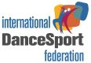 | MINISTRY OF UKRAINE ON AFFAIRS OF  FAMILY, YOUTH AND SPORTS  INTERNATIONAL DANCESPORT FEDERATION  ALL-UKRAINIAN DANCESPORT FEDERATION  DANCESPORT CLUB «SLAVUTICH STAR» | 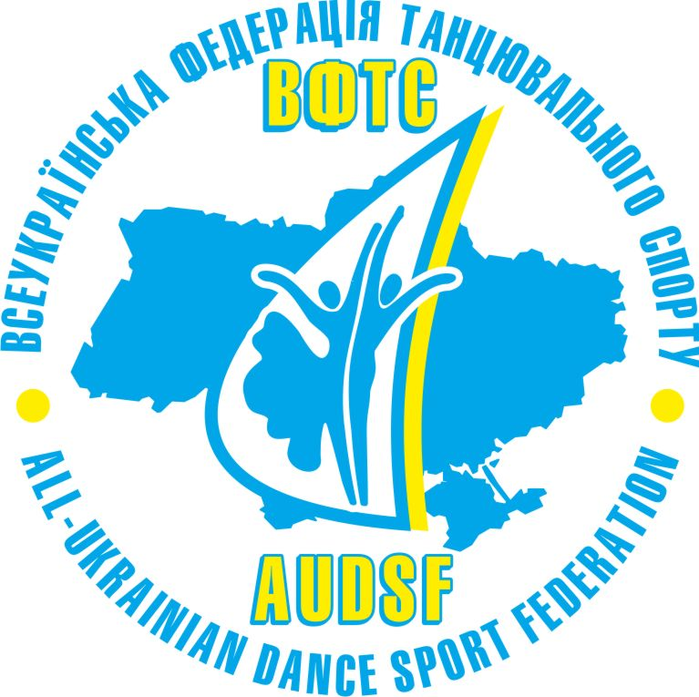

X-th International Dance Sport Competition

«SLAVUTICH CUP-2010»
Ukrainian Championship Youth Standart
Ukrainian Cup Adult Latin 10 dance
IDSF International Open Latin
IDSF Open Standart

Sport Complex “Olimpiyets”, Slavutych, Ukraine 27-28 march 2010 year

 |  | 27 march |  |  | 28 march
 |  | 10:00 | 14:00 | 19:00 | 10:00 | 14:00 | 19:00
1 | Ukrainian championship  Youth | St
2 | Ukrainian cup  Adult |  | 10 dance
3 | Ukrainian cup  Adult |  |  |  | La (12.00)
4 | Juveniles 1 H | W,Q,Ch,J
5 | Juveniles 1 |  |  | 6 dance
6 | Juveniles 2 H | W,Q,Ch,J
7 | Juveniles 2 Е | 6 dance
8 | Juveniles 2 |  | 4La,4St
9 | Juniors 1 E | 6 dance
10 | Juniors 1 Д | 4 St, 4La
11 | Juniors 1 C |  |  |  | 5 St, 5La
12 | Juniors 2 Д | 4 St, 4La
13 | Juniors 2 C | 5 St, 5La
14 | Youth + Adult Hobbi |  |  |  |  | 4 St, 4La
15 | Youth + Adult С+B | St |  |  | La
16 | Juniors 1 |  | La | La (final) |  | St | St (final)
17 | Juniors 2 |  | La | La (final) |  | St | St (final)
18 | Youth |  | St |  |  | La
19 | Adult IDSF |  | Open St (16.00) | Open St 1/2 |  | International Open La (15.00) | International Open La 1/4

IDSF Open Standart, IDSF International Open Latin: money awards for final pairs
Finalists of other categories are awarded by medals, cups and valuable prizes from sponsors of tournament

Judges: 11 international judges from different Nationalities in each category
Dress: IDSF Rules must be applied
Entry: Please, send your entry no later, than March 20, 2010 svb_70@voliacable.com svb-70@mail.ru
Hotel reservation: Please, call tel: +380506222593(Irina) for hotel reservation (from 8 euro)
On-Line Check-in: www.adsf.com.ua
Starting fees: Per couple for one program: All groups – Euro 15;
Youth+Adult – Euro 25
Adult IDSF – Euro 25
Ticket prices per person: – 1-2 part – 4 euro, 3 part from – 6 euro

With the best regards and to a meeting on tournament!
The responsible organizer: Sovetchenko Vadym tel.: +380504651033, +380445138827
svb_70@voliacable.com
svb-70@mail.ru

IDSF ADJUDICATORS
Italy Wilkinson Johanne
Latvia Sinkins Sergejs
Lithuania Gunko Gennadius
Moldavia Varnacov Artur
Netherlands Jager Yvette
Poland Smirnov Yolodymyr
Romania Strelnyk Dmytro
Russia Davydova Larisa
Slovenia Novak Daniela
Byelorussia Kazyra Alexandr
Estonia Korotin Eduard
France Neudeck Juergen

CHAIRMAN Moldavia Gozun Petru

Сайт соревнований: http://slavutichcup.ideasforyou.ru/

г.Славутич расположен в 60 км. от г.Чернигова и 180 км. от г.Киева

По вопросам заказа микроавтобусов связывайтесь по тел +380506222593 (Ирина)

Ориентировочная стоимость проезда на микроавтобусе (18 мест) по маршрутам: Чернигов-Славутич – 15 грн (2$) Киев-Славутич 45 грн (6$)

