 | MINISTRY OF UKRAINE ON AFFAIRS OF FAMILY, YOUTH AND SPORTS  International DanceSport Federation (IDSF)  All-Ukrainian DanceSport Federation (AUDSF)  Club of Sport and Modern Dances «Leader», Lviv | 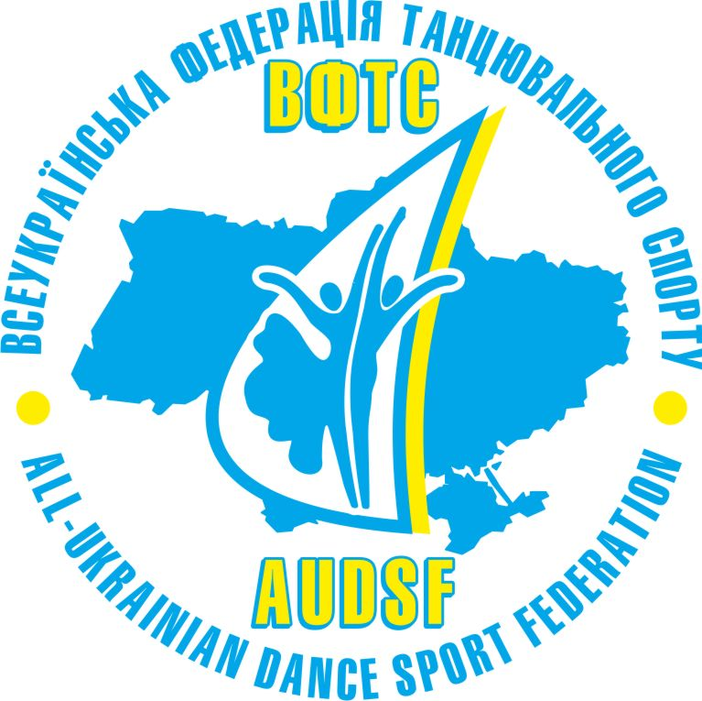
16th Traditional Open International competition

“Ukrainian Titles-2010”
IDSF OPEN STANDARD, UKRAINIAN CHAMPIONSHIP AND CUPS
Date: 13th - 14th November, 2010
Place: The biggest in the Western Ukraine Shopping & Entertainment centre "Podolyany",
Tekstylna Str 28, Ternopil (the nearest airport- Lviv), Ukraine www.podolyany.com.ua
Categories | Saturday, 13th November |  |  |  | Categories | Sunday, 14th November
Rehearsals - 9:00,12:50,15:50,18:50 | 10.00 | 13.00 | 16.00 | 19.00 | Rehearsals -10:00,13:50,18:50 | 11.00 | 14.00 | 19.00
Juveniles I E (2001..) | 3 St,3 La |  |  |  | School – baby 1(5-6),  School –baby 2 (7-8) | W, Ch, polka
Juveniles II E (00 –99) |  | 3 St,  3 La |  |  | Scholl А (under 8),  School В (9-10) | W, Ch, J
Juniors I E (98 – 97) | 3 La | 3 St |  |  | School С (11-12)  School D (13- 15) | W, Ch, J
Juniors II E (96 – 95) |  | 3 St | 3 La |  | School hobby  16 and older | W,S,Ch,J
Juniors I D (98-97) | 4 St | 4 La |  |  | Lady solo juveniles under 11 | W, Ch, J
Juniors II C  Juniors II B | 5 St  5 St | 5 La  5 La |  |  | Lady solo:  juniors 12-15,  15 and older | W,S,Ch,J
Juniors II D (96-95) | 4 St |  | 4La |  | School 1 (7-8),  School 2 (9-10) | W,Q,Ch,J
Hobby beginners- 1  16-24 | W,Q,S  Ch,J |  |  |  | School 3 (11-12) ,  School 4 (13-15) | W,Q,Ch,J
Hobby beginners- 2  25 and older | W,Q,S Ch,J |  |  |  | Juveniles I beginners (2001…) |  | W,Q,Ch,J
Seniors beginners |  | W,Q,Ch,J |  |  | Juveniles II beginners (2000-99) |  | W,Q,Ch,J
Youth + Adults Е |  | 3St | 3La |  | Juniors I beginners |  | W,Q,Ch,J
Youth +Adults D |  | 4St | 4La |  | Juniors II beginners |  | W,Q,Ch,J
Youth+Adults В |  |  | St |  | Juveniles I D | 4 St,4 La
Juveniles I (2001…) |  | 4 La |  |  | Juveniles II D | 4 La,4 St
Juveniles II (00 –99) | 4 St,4 La |  |  |  | Youth+Adults С |  | La | St
Juniors I (98 – 97) |  |  |  | La | Juniors I (98 – 97) |  |  | St
Juniors II (96 – 95) |  |  |  | St | Juniors II (96 – 95) |  | La
Youth |  | St |  |  | Youth |  | La
Seniors |  |  |  | St | Seniors |  |  | La
Adults IDSF Open |  |  | St | ½, F | Youth+Adults В |  |  | La
Wiener Waltz CUP |  |  |  | WW | Adults |  |  | La
UKRAINIAN CHAMPIONSHIP |  |  | Juv 1  ST |  | UKRAINIAN CUPS |  | Junior 1 Lat | Junior 2, 10 dances
Judges: from Belarus, Italy, Hungary, Lithuania, Moldova, Poland and Ukraine.
Dress: IDSF Rules must be applied! Information: Irena Bous’ , tel.mob. 00 38 050 506 00 11.
Entry: please, send your entry no later than, 27th October, 2010 to the e-mail: info@udb.com.ua or tel/fax: 00-38-032-261-11-04 (working time 9.00 – 17.00). Hotel: special price for dancers

