

The ministry of physical culture and sports of Ukraine
International dance sport association
City executive administration of Yuzhny
Dance club “PROFI” and dance club “YUZHNY”

Yuzhny Major Cup 2008

13-14 September
IDSA+IDU World Championships Latin and Standart
IDU World Championships 10 Dances

Place of carrying out: Yuzhny, sport palace “OLIMP”

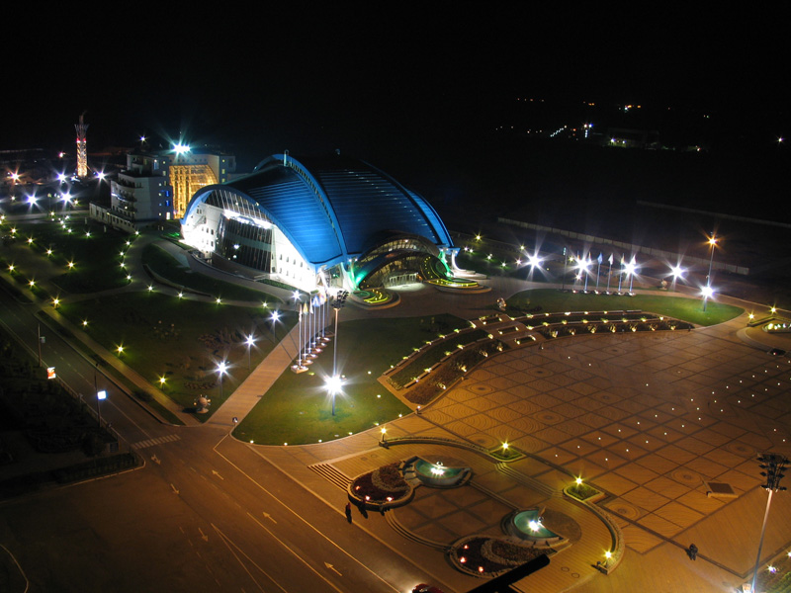

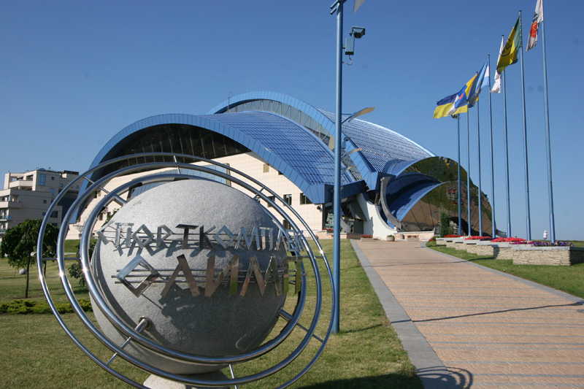

Yuzhny Major Cup 2008
GROUP | 13 September |  |  | 14 September
GROUP | 09.30 | 15.00 | 19.00 | 09.30 | 14.00 | 19.00
Baby |  |  | St |  |  | La
Girls juveniles I | W,Ch,J
Girls juveniles II |  |  |  | W,Q,Ch,J
Girls juniors I |  |  |  | Ch,S,J | W,T,Q
Girls juniors II |  |  |  | Ch,S,R,J | W,T,Vw,Q
Children beginners |  |  |  | W, Ch,J,
Juveniles I beginners |  | W,Q,Ch,J
Juveniles I E | La |  |  | St
Juveniles II beginners | St | La
Juveniles II E | St | La
Juveniles I + II D | La |  |  | St
Juniors I beginners | La | St
Juniors I E | La | St
Juniors I D | St |  |  | La
Juniors I C |  | St |  |  | La
Juniors II E |  |  |  | St | La
Juniors II C |  | St |  |  | La
Hobby (after 18) |  | La |  |  | St
Hobby (under 18) |  | La |  |  | St
Juveniles I (under 10) major cup |  | St |  |  | La
Juveniles II (under 12) major cup |  |  | La |  |  | St
Juniors I (under 14) major cup |  |  | St |  |  | La
Juniors II (under 16) major cup |  |  |  |  | La
Youth (under 19) major cup |  |  |  |  | St
Youth (under 21) major cup |  |  | St |  |  | La
Adult major cup |  |  | St
W and S major cup |  |  | W |  |  | S
IDU World Championships Juniors II (under 16) |  |  | 10 dances
IDSA+IDU World Championships Juniors II (under 16) |  |  |  |  |  | St
IDSA+IDU World Championships Youth (under 19) |  |  | La
IDSA+IDU World Championships Adult |  |  |  |  |  | La
Judges: all judges from different Associations
Dress: IDSA Rules must be applied!
Starting fee: Per couple for one program:
W and S, Girls- 10Є. Beginners, Е, D,C class – 20Є. Juveniles, Juniors, Hobby—25Є. Youth, Adult –30Є.
Prize money for IDSA+IDU World Championship Latin and Standart:
Adult – places: 1st-3000$, 2^{nd-}2000$, 3rd -1500$, 4th-900$, 5th-800$, 6th-700$,
7th-600$, 8th-500$, 9th-400$, 10th -300$, 11th-200$, 12th-100$.
Under 19 – places: 1st-800$, 2nd-600$, 3rd-400$, 4th-300$, 5th-200$, 6th-100$.
Under 16 – places: 1st-600$, 2nd-500$, 3rd-400$, 4th-300$, 5th-200$, 6th-100$.
For other finalists beautiful prizes, diplomas, medals and cups.
Hotel price: from 10 Є to 300 Є per one person/night. Please, send your entry no later than 20 August 2007.
Entry: Please, send your entry no later than 1 September 2007.
Tickets: from 5Є to 10Є. For a reserve of tables call to organizers.
Dance Sport Club “PROFI”  Mr. Alex Gotsulyak  48-1/16, Koroleva str., Odessa  Ukraine  Phone: +380 97 3527032  E-mail: algcemcem@mail.ru | Dance Sport Club ”Dinamo –Illichevsk”  Mr. Victor Paliy  14 Solyana str., Odessa  Ukraine  Phone: +380 67 712 74 76  Fax:+ 380 48 2678735, mob. + 380 48735 85 38  E-mail: dinamoilichevsk@ukr.net

